Lesson 3 Matterhorn man

alpinist ['ælpɪnɪst]

n. （阿尔卑斯山的）登山者

alpinist / Alpinist

mountain climber mountaineer mountain climbing mountaineering alpinism / Alpinism

the Alps

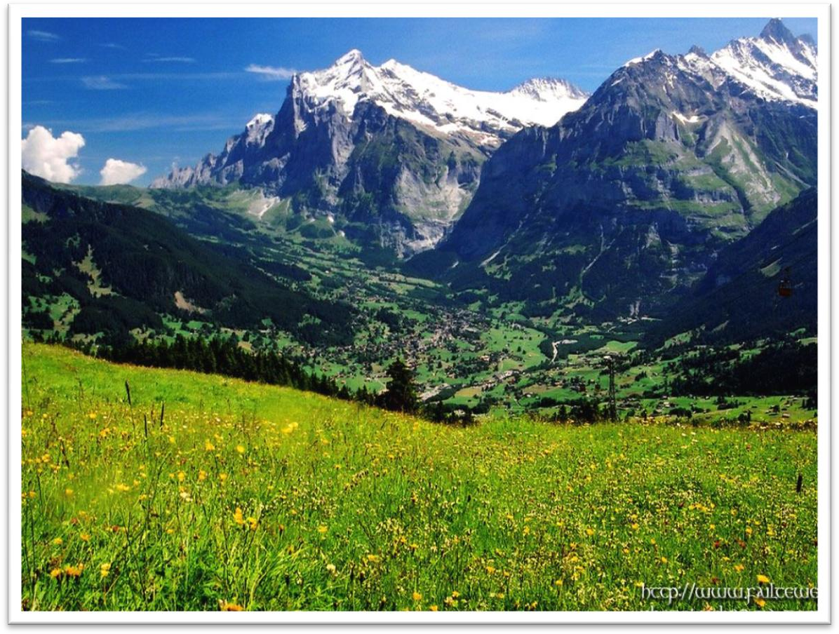

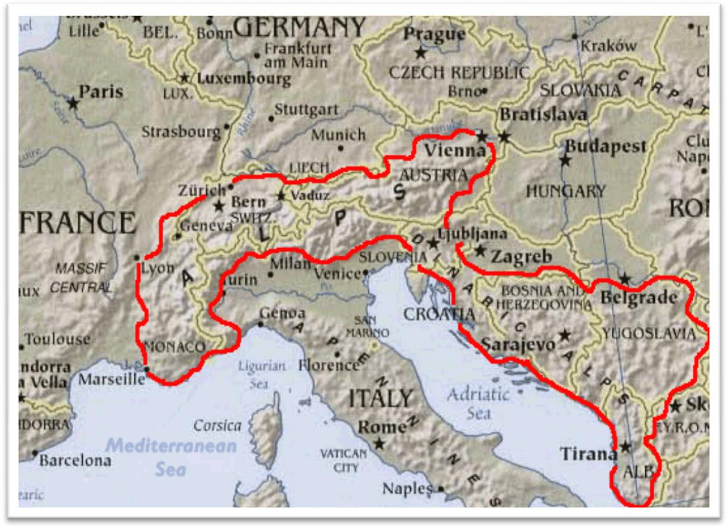

Mont Blanc

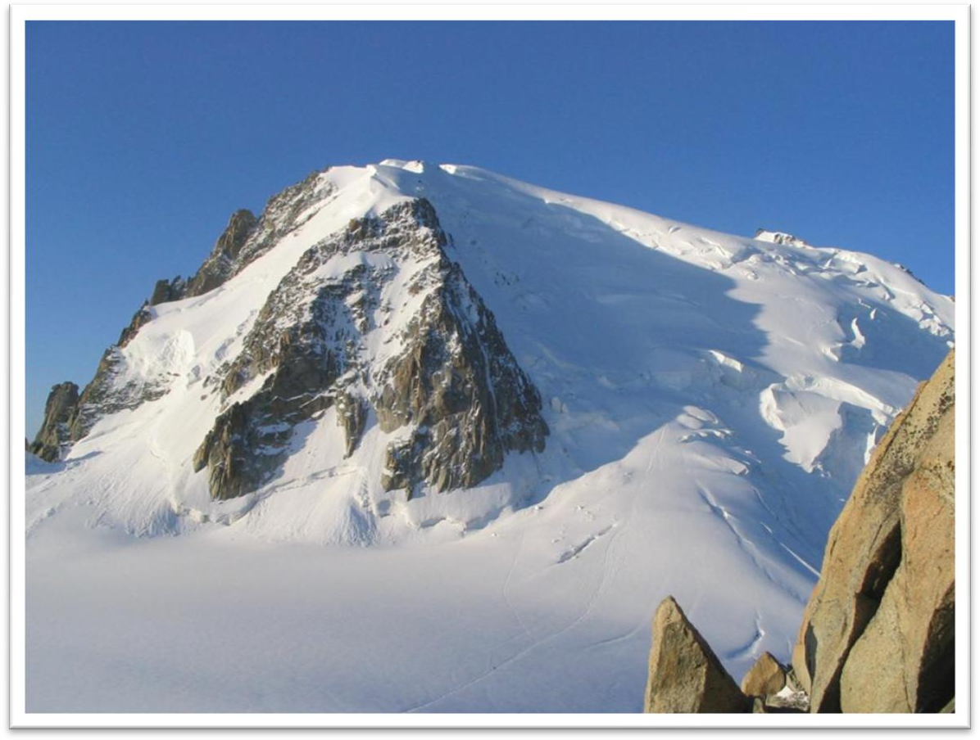

Mont matterhorn

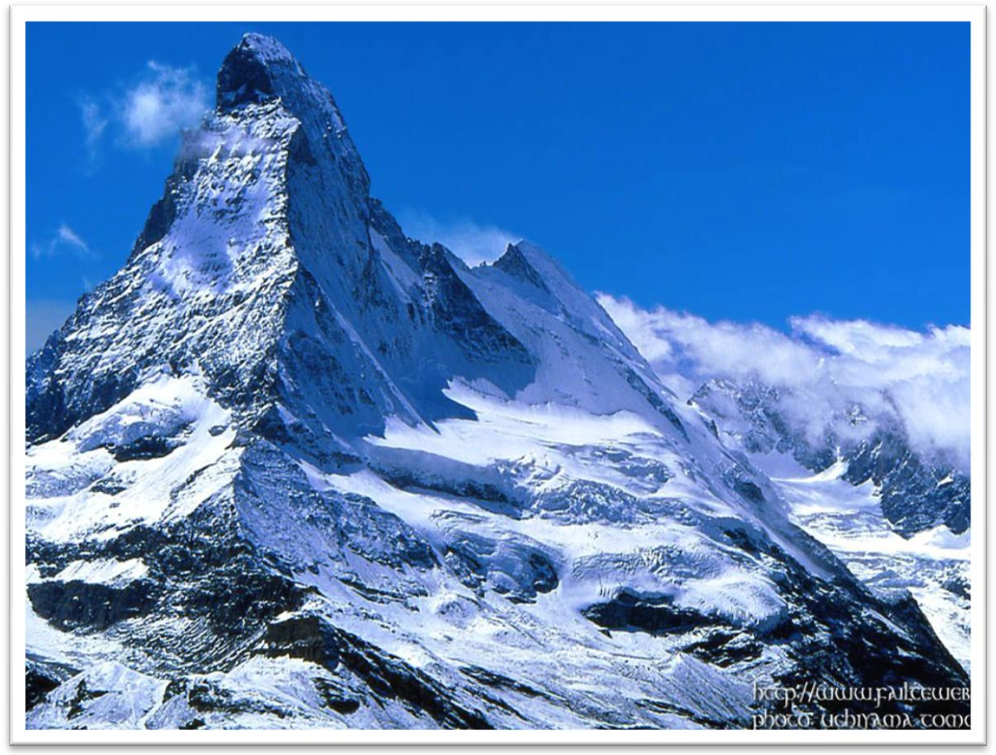

Chamonix the cradle of modern mountaineering

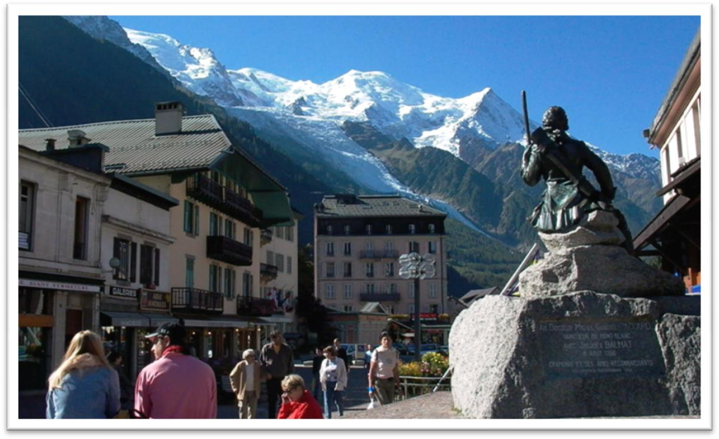

Alpine / alpine alpine villages

breathtaking alpine scenery pioneer [7paɪə'nɪə(r)]

n. 先驱，探索者；v.开拓，探索

Young Pioneers

Henry Ford was a pioneer in the auto industry. The Wright brothers pioneered in early aviation. pioneering

pioneering work pioneering spirit

in the pioneering days break new ground

Deng Xiaoping’s reform programs broke new ground in China. ground-breaking educational reforms

lead the way

The company has led the way in developing environment-friendly products.

summit ['sʌmɪt]

n. 山顶，顶点；峰会

summit / peak

the summit / peak of his career

The two presidents agreed to hold a summit in the coming spring.

They hope to finish in time for a trade summit between America and the EU on May 28th.

crest pinnacle

the crest/pinnacle of one’s career apex

the apex of a triangle the apex of one’s career zenith

At the zenith of its power, the Yuan Dynasty ruled almost all of the Eurasian continent.

perilous ['perələs]

adj. 非常危险的

a perilous journey across the mountains

perilous country roads peril

The ship was in grave peril. hazardous

a hazardous investment

Being the President’s bodyguard is a hazardous occupation. hazard

a health / safety / fire / traffic hazard

be / present / pose / constitute a hazard to …

The busy traffic entrance is / presents / poses / constitutes a hazard to pedestrians.

Our knowledge of the oceans a hundred years ago was confined to the two-dimensional shape of the sea surface and the hazards of navigation presented by the irregularities in depth of the shallow water close to the land.

be / present / pose / constitute a threat / menace to …

Inflation may pose a potential threat to China’s social stability.

Religious extremism constitutes a grave menace to the security and stability in the region.

shudder ['ʃʌdə(r)]

v. 颤抖，不寒而栗

She shuddered at the thought of the murder. The ship shuddered when she struck the rocks. tremble shiver quiver

Suddenly, there was a slight trembling sound from below, and the captain went down to see what had happened.

He trembled *with anger / fear / excitement*. When I kiss your lips, ooh I start to shiver, Can’t control the quivering inside.

Wouldn’t you agree, baby you and me got a groovy kind of love.

court [kɔ:rt]

v. 追求

A friend in court is better than a penny in purse. courtesy courteous

go to court

settle sth. out of court

a tennis / basketball court

Some businessmen court only wealthy clients. John has been courting Mary for 3 years. court fame and gain

Pride courts failure. solitary ['sɒlətri]

adj. 唯一的

Beckham scored the solitary goal of the game. They had a single aim, a solitary goal—top ! solitude

loneliness

Perhaps it is the desire for solitude or the chance of making an unexpected discovery that lures people down to the depths of the earth.

I love tranquil solitude.

— P. B. Shelley

in solitude

I spent the morning in solitude.

I live in that solitude which is painful in youth, but delicious in the years

of maturity.

— Albert Einstein

“*sol* ” = alone sole

solo soliloquy

impoverish [ɪm'pɒvərɪʃ]

v. 使贫困

The EU trade policies will impoverish developing countries. deplete

Solar storms deplete ozone layer. impoverished

destitute

the institute for the destitute deprived

disadvantaged underprivileged

underdeveloped countries / regions …

flea-ridden [fli: 'rɪdn]

adj. 布满跳蚤的

flea flee (fled, fled)

When Mrs. Richards walked towards him, he fled, slamming the door behind him.

“*-ridden* ”: full of sth. unpleasant debt-ridden countries

mosquito-ridden swamps disease-ridden slums

“*-infested* ”

shark-infested waters rat-infested warehouses insect-infested trees boast [bəʊst]

v. 炫耀，自夸；拥有

boast of / about sth. boast that …

Every salesman boasts of his own wares.

Bush boasted that the world was safer with Saddam hanged. China and France boast sound bilateral relations.

China and the EU boast consensus on environment. enjoy

The city at one time must have been prosperous, for it enjoyed a high level of civilization.

be blessed with …

They were blessed with two children, a boy and a girl. be endowed with …

She is endowed with both brains and beauty. Declaration of Independence

We hold these truths to be self-evident, that all men are created equal, that they are endowed by the Creator with certain unalienable rights, that among these are life, liberty, and the pursuit of happiness.

― Thomas Jefferson

cherish

Like a scientist bent on making a discovery, he must cherish the hope that one day he will be amply rewarded.

He cherished the memory of his late wife. be free from …

The composition is free from errors.

Organic produce is free from harmful chemicals.

He may never be sure where the next meal is coming from, but he is free from the thousands of anxieties which afflict other people.

parishioner [pə'rɪʃənə(r)]

n. 教区居民

parishioner

parish church

diocese cathedral

church cathedral

Modern alpinists try to climb mountains by a route which will give them good sport, and *the more difficult it is*, the more highly it is regarded. modern

modern-day present-day today’s … … of today

contemporary

sport n. [U] fun; amusement

Swimming in the sea will give you good sport.

He tormented the cat only for sport.

On the occasions when they have pushed to shore an unconscious human being they have much more likely done it out of curiosity or for sport, as in riding the bow waves of a ship.

…which will give them good sport, …

➔ …which will give them good / a lot of fun, …

*a* good sport

Hey, man! Be a good sport! a bad / poor sport

a sore loser

The younger the child is, the more is the child’s need of sleep. The younger the child, the more the child’s need of sleep.

The stronger the magnet, the greater the number of lines of magnetic force.

The stronger the magnet is, the greater is the number of lines of magnetic force.

The higher the standard of living, the greater the amount of paper used. The higher the standard of living is, the greater is the amount of paper used.

The greater the percentage of such customers, the weaker the argument’s

evidence as an indication of customer satisfaction with the change.

The greater the percentage of such customers is, the weaker is the argument’s evidence as an indication of customer satisfaction with the change.

I play (the) better, the more I practice. The more I practice, the better I play.

A compound is considered the more stable, the smaller its potential energy.

We are so familiar with the fact that man ages, that people have for years assumed that the process of losing vigour with time, of becoming more

likely to die the older we get, was something self-evident, like the cooling of a hot kettle or the wearing-out of a pair of shoes.

A telescope would have to be as far away as the planet Jupiter to look for life in outer space, because the dust becomes thinner the further we travel towards the outer edges of our own solar system.

One would expect them to know their parts by heart and never have cause to falter. Yet this is not always the case.

No one suspected that there might be someone else on the farm who had never been seen. This was indeed the case.

This is not the case at all. This is not always the case.

This is indeed the case.

This is not necessarily the case. This might not be the case.

The early climbers were looking for the easiest way to the top, because the summit was the prize they sought, *especially if it had never been attained before.*

the pioneers

the pioneer climbers their predecessors

Sometimes we go upstream to a favorite backwater, sometimes we have our party at the boathouse, which a predecessor of ours at the farm built in the meadow hard by the deepest pool for swimming and diving.

sense of pride / honor / accomplishment

I came, I saw, I conquered! Julius Caesar

Veni, vidi, vici.

seek v. try to achieve sth. seek refuge / asylum

seek compensation seek advice

The incumbent president will not seek reelection.

Virgo woman seeks Scorpio man

It is true that during their explorations they often faced difficulties and dangers of the most perilous nature, *equipped in a manner which would*

*make a modern climber shudder at the thought,* but they did not go out of their way to court such excitement.

It is / was true that … , but …

It was true that he had just bought a lamb, he explained, but his lamb was black.

造句：中国确实还是一个发展中国家, 但是她却充满了潜力。

It is true that China is still a developing country, but she is full of potential / potentialities.

Admittedly, / Granted, … but …

Granted, a snobbery of camping itself, based upon equipment and techniques, already exists; but it is of a kind that, if he meets it, he can readily understand and deal with.

It is true that / admittedly, / granted, …, but / yet

that is not to say that …

it does not necessarily mean that … we cannot ensure / guarantee that … there is no guarantee that …

face confront

be faced / confronted with …

China is faced / confronted with the problem of overpopulation.

But if the animals are confronted with situations they have no control over, they later behave passively when faced with experiences they can control.

I can’t approve of things *of* this nature.

*of* a … nature

treaties *of* a political nature books *of* an erotic nature questions *of* an academic nature articles *of* a technical nature

be equipped with …

The city was even equipped with a drainage system, for a great many clay pipes were found beneath the narrow streets.

at the thought of *the manner*

at the … of … 一……就……

… your stomach would turn at the idea of frying potatoes in animal fat …

… they always go into raptures at the mere mention of the country … She screamed at the sight of the murder.

She woke at the sound of the bell.

She fainted at the news of her father’s death.

造句: 防暴警察(riot police)在体育场外巡逻(patrol the stadium)，装备得使足球流氓(soccer hooligan)一看到就不寒而栗。

Riot police were patrolling the stadium, equipped in a manner which would make a soccer hooligan shudder at the sight.

go out of one’s way (to do …)

Please don’t go out of your way for me.

It was very kind of you to go out of your way to meet us at the airport.

虚情假意山盟海誓千刀万剐深仇大恨

I’m sick and tired of your silliness. He is never one to pick and choose.

She is always complaining of her aches and pains.

It is hard *for us* to realize nowadays how difficult it was for the pioneers.

*Except for one or two places such as Zermatt and Chamonix, which had*

*rapidly become popular*, Alpine villages tended to be impoverished settlements cut off from civilization by the high mountains.

except for / but for … 除了……

except for / but for / if it were not for … 若没有……的话

except for / but for / if it were not for your support, I would be in big

trouble now.

Insects would make it impossible for us to live in the world; they would

devour all our crops and kill our flocks and herds, if it were not for the protection we get from insect-eating animals.

except / but (that) …

I would buy a Mercedes except / but (that) I poor. if I were rich.

Zermatt

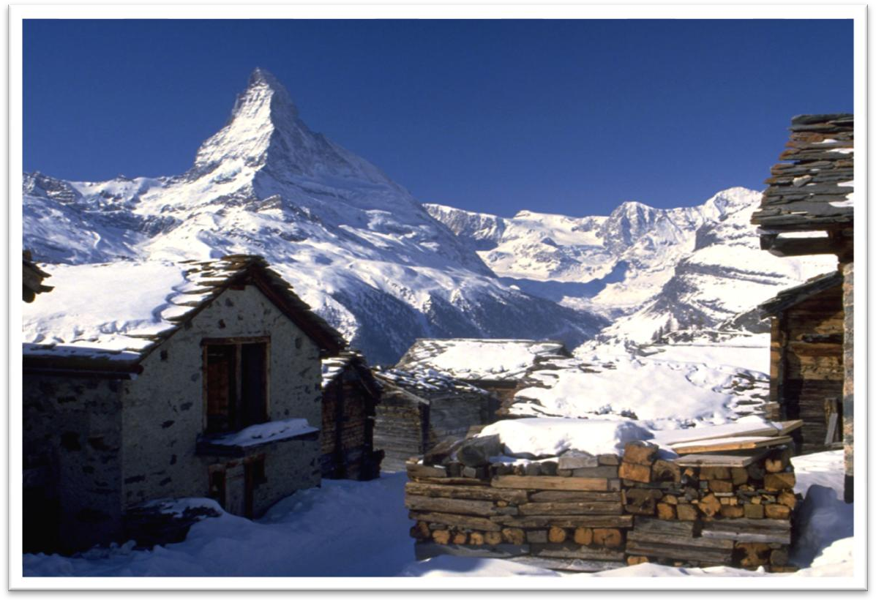

Chamonix the cradle of modern mountaineering

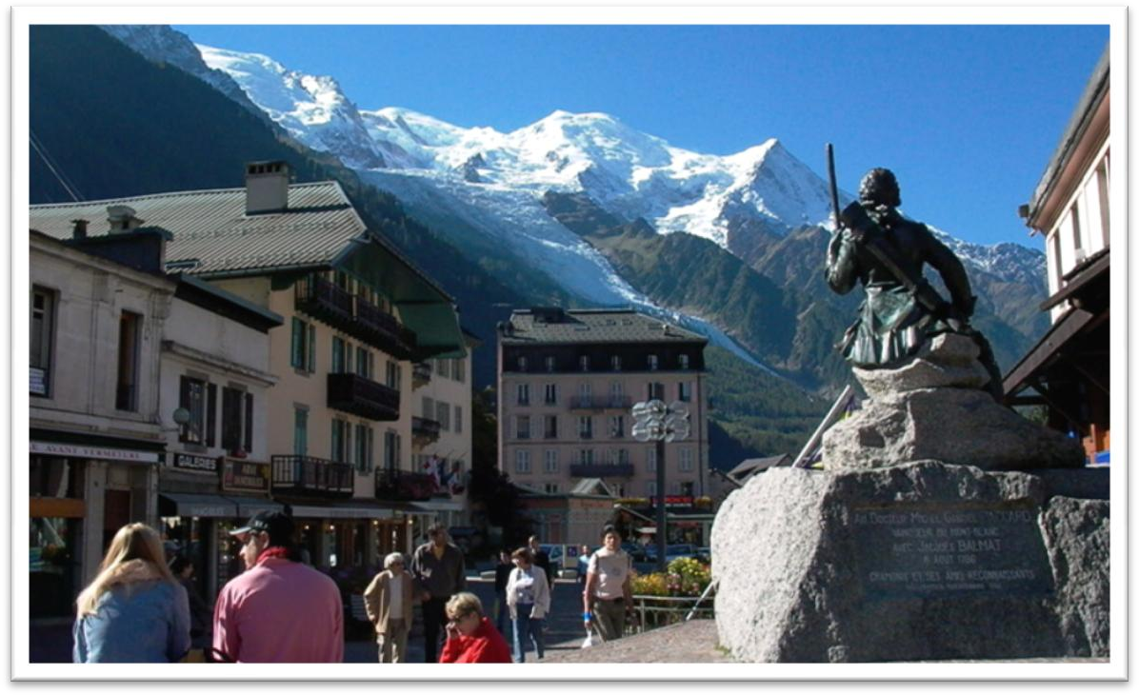

tend to do

People tend to need less sleep when they get older. Women tend to live longer than men.

have a tendency to do

The drug is effective but has a tendency to cause headaches.

|  |  |
| --- | --- |
| generally | In general |
| Mostly | In most cases |
| On the whole | By and large |
| For the most part | Most of the time |

(which were) cut off from

out of touch with civilization

isolated from separated from

Such inns as there were were generally dirty and flea-ridden; the food simply local cheese accompanied by bread often twelve months old, *all*

*washed down with coarse wine*.

Inn

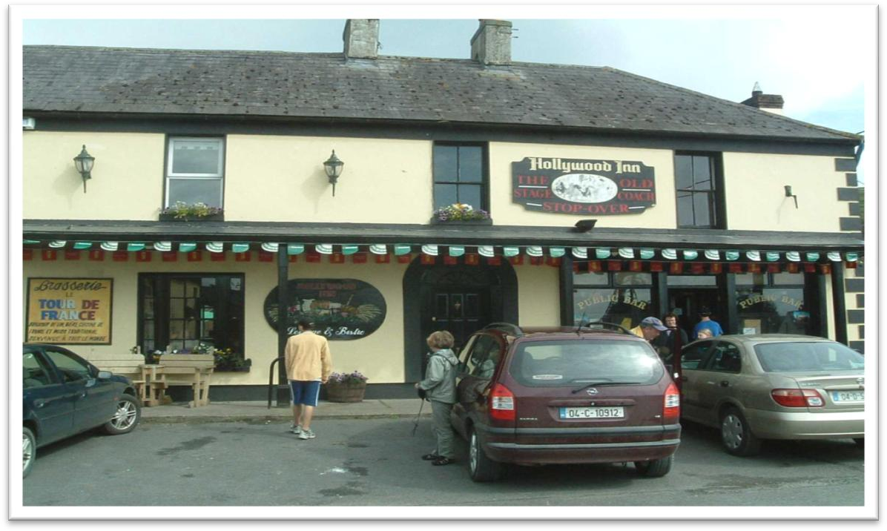

such / the same / as / so … as …

I need *the same* tool as you are using. I need *such* a tool as you are using.

I need *as* useful a tool as you are using.

Such inns as there were *tended to be* dirty and flea-ridden; …

…; the food *(was)* simply local cheese accompanied by bread often 12 months old.

…, for a spider always has eight legs and insect never (has) more than six.

Paul likes poetry, and Peter *(likes)* fiction.

Paul likes poetry, and I know that Peter *likes* fiction. accompany

The disease is accompanied by sneezing and fever.

Chinese President Xi Jinping, accompanied by his wife Peng Liyuan, is undertaking a state visit to the United Sates.

wash sth. down with sth.

We ate some sausage, and washed it down with whiskey.

Often a valley boasted no inn at all, and climbers found shelter wherever

they could—*sometimes with the local priest (who was usually as poor as*

*his parishioners), sometimes with shepherds or cheese-makers.*

find one’s way

Specially-made lanterns are hung outside each house to help the dead to find their way.

My nephew, George, has a money box but it is always empty. Very few of the fifty pence pieces and pound coins I have given him have found their way there.

threaten to do

We keep trying all four methods, but the sheer volume of rubbish we

produce worldwide threatens to overwhelm us. promise to do

Groundbreaking research by two French geophysicists promises to shed some light on the mystery.

Food, clothing, shelter and transportation are basic necessities of daily life.

Invariably the background was the same: dirt and poverty, and very

uncomfortable.

*For men accustomed to eating seven-course dinners and sleeping*

*between fine linen sheets at home*, the change *to the Alps* must have been very hard indeed.

Men accustomed to struggling for survival against the elements and Indians were bewildered by politicians, bankers and businessmen, and unhorsed by fences, laws and alien taboos.

be accustomed to sth. / doing

be used to sth. / doing

be in the habit of sth. / doing